BIT 4107 – Mobile Application Development
STUDENT LOGBOOK
- Student Name: Prince Wilfred Wachira
- Admission Number: BIT/2024/56303
- School/Faculty: School of Pure and Applied Sciences / Department of Information Technology
- Program : Bachelor of Science in Information Technology
- Academic Year: 2025/2026
- Semester: September 2024 Intake
- Lecturer: Michael Nyoro
- Phone Number: 0796478918
This logbook documents weekly learning activities, practical exercises, skills acquired, challenges encountered, solutions applied, and reflections. Students should complete all sections every week.
Week 1: Introduction to Mobile Application Development
- Practical Activities Undertaken: Reviewed baseline project setup constraints and verified syntax schemas.
- Screenshots/Evidence Attached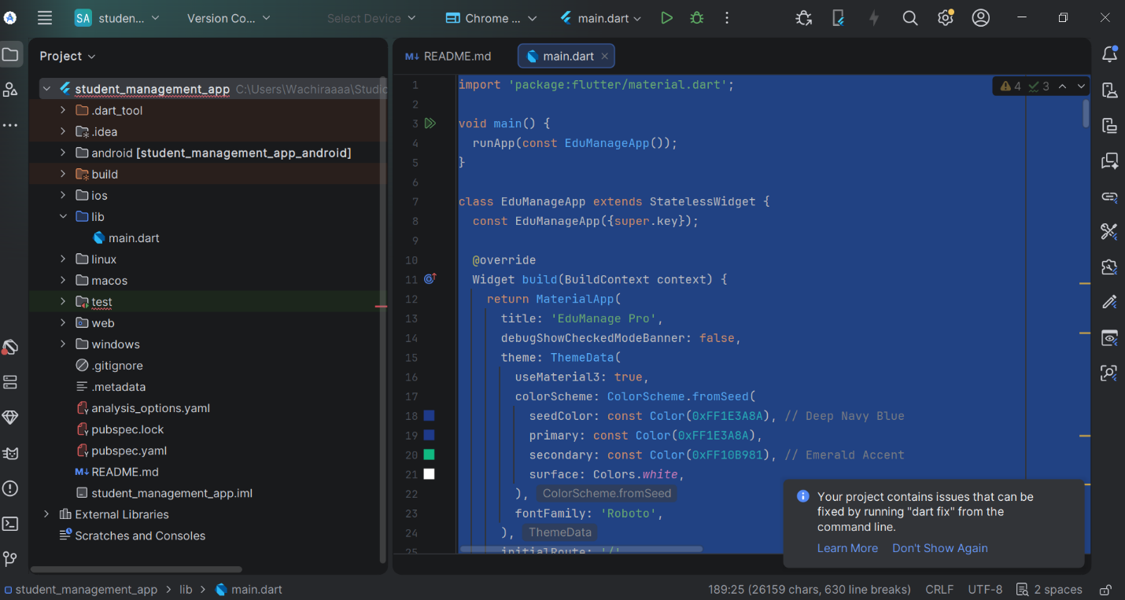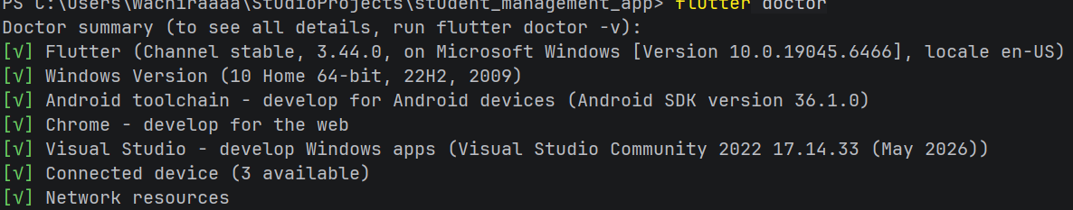
- Tools/Software Used: Flutter SDK, Dart Engine, Git
Week 2: Mobile Development Environment
- Practical Activities Undertaken: Executed comprehensive machine configuration diagnostics and environment status evaluations using systemic terminal commands.
- Screenshots/Evidence Attached: Yes

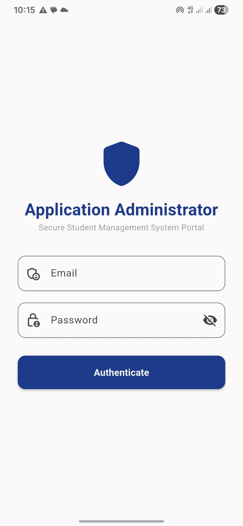
- Tools/Software Used: Windows PowerShell, Flutter Doctor CLI, Visual Studio Community 2022
Week 3: User Interface Design
- Practical Activities Undertaken: Implemented structured Material 3 application administrative portals focusing on layout symmetry and input fields.
- Screenshots/Evidence Attached: Yes
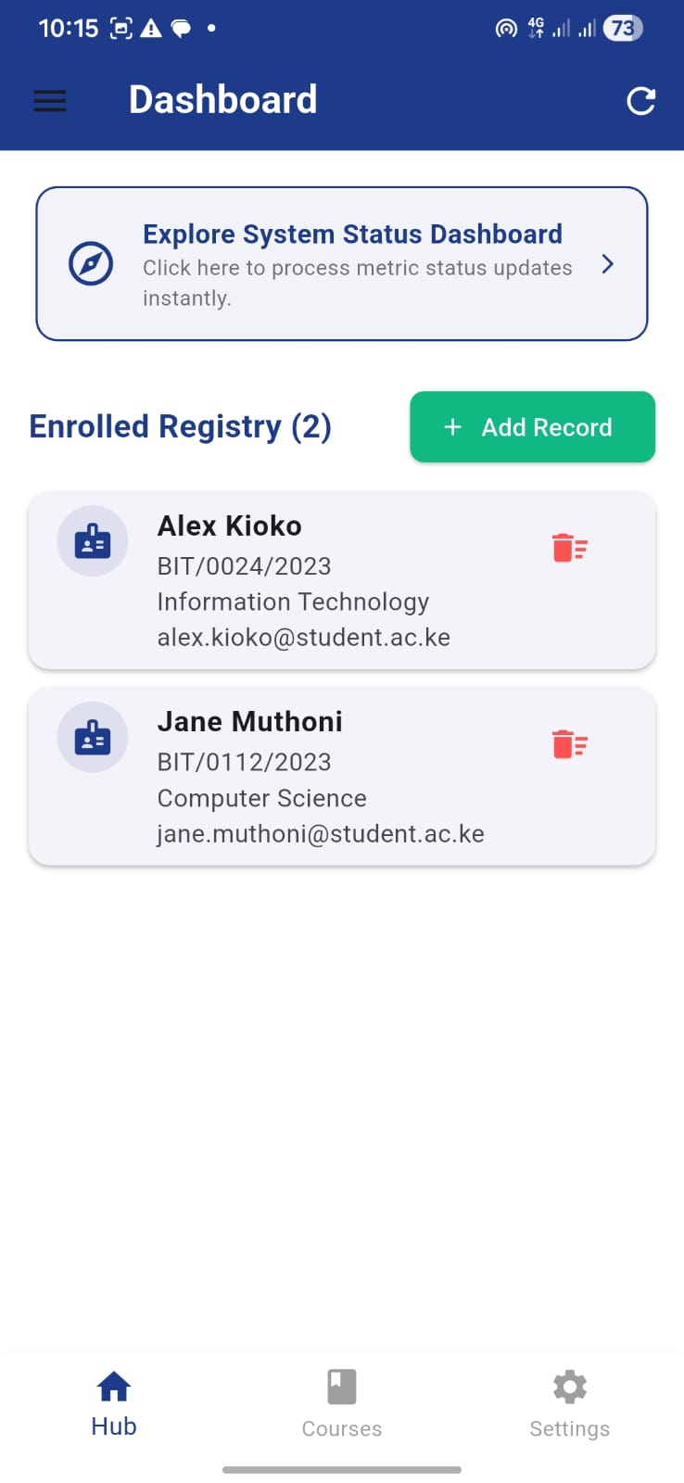

- Tools/Software Used: Flutter UI Engine, Dart Layout System, Android Virtual Device
- Personal Reflection: Designing a responsive login screen helped me balance form validation with clean user interfaces, improving interactive application design.
Week 4: Event Handling and User Interaction
- Practical Activities Undertaken: Constructed main system entry dash interfaces processing state mutations and handling reactive form validation.
- Tools/Software Used: Android Studio, Flutter State Management, Material Design Icons

Personal Reflection
Developing EduManage Pro for my BIT4107 project deepened my understanding of building mobile administrative systems in Flutter. Designing secure authentication, implementing structured routing pipelines, and managing modular UI layers for real-world scenarios sharpened my software architecture skills, reinforcing best practices for student registry data management.

